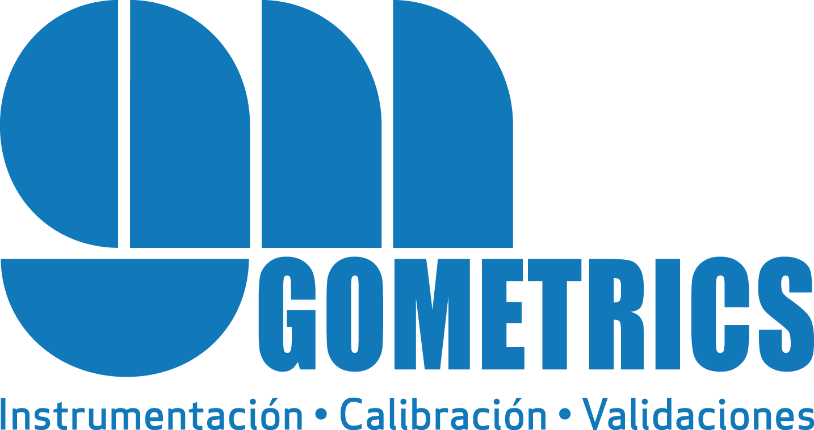

Gometrics, over 40 years of experience in process instrumentation and calibration
GOMETRICS is a high-tech company specialized in process instrumentation and calibration.
We develop precision instruments for the industry to help the technicians in industrial calibration, control and maintenance processes in which the temperature, pressure and gas flow are of particular importance.
Our professional team is committed to the continuous improvement and technical quality of our solutions and service excellence.
Building on a specialization started by its founders over 40 years ago, Gometrics today provides reliable calibration solutions and recording, regulating, alarm and control systems for the most common process magnitudes in the industry.

Through exclusive agreements with leading companies in their fields, making them genuine strategic partners, we are able to offer the most suitable process control, instrument calibration and maintenance solutions. Currently, we are official representatives in Spain for worldwide leading brands such as Beamex, Furness Controls, United Electric, Dk-Lok and EP-E.

Since a few years ago, Gometrics products are present in the international market.

Our areas of technical expertise are temperature, pressure, electric signals, gas and liquid flow, humidity, etc...

Our specialized technicians carry out calibration services both in our laboratory premises and on site. Gometrics holds an ENAC EN17025 accreditation in temperature, pressure and humidity.
As manufacturers we are able to adapt to your requests.

We take care and we respect the environment, as well as the safety of our customers and workers.
Contact details: Anna Mellado / T. 93 864 68 43 (ext. 101) / e-mail: info@gometrics.net

Gometrics Barcelona
Pol. Ind. Riera de Caldes c/ Basters, 17 - 08184 Palau-Solità i Plegamans, Barcelona.
T. +34 93 864 68 43 - info@gometrics.net

Gometrics Zona Centro
Ctra. Vicálvaro a Est. O’Donell 2B 1A - 28032 Madrid.
T. +34 91 371 00 42 - zcentro@gometrics.net

Gometrics Zona Norte
48001 Bilbao.
T. +34 692 52 63 57 - znorte@gometrics.net

www.gometrics.net
www.thegasmixer.com

Our partners
